Records

Logistics Case Study

IVF6ILV

Integrated Value Flows

**Created on:** 03 March 2025

**Author:** Fabian Zaiser

Table of Contents

SD Challenge 3

Task 3

Datasheet 3

Process steps 3

Step 1: Create .... 3

Step 2: Create .... 3

PP Challenge 4

Task 4

Datasheet 4

Process steps 4

Step 1: Create .... 4

Step 2: Create .... 4

MM Challenge 5

Task 5

Datasheet 5

Process steps 5

Step 1: Create .... 5

Step 2: Create .... 5

Logistics Case Study 6

Task 6

Datasheet 6

Process steps 6

Step 1: Create .... 6

Step 2: Create .... 6

# SD Challenge

## Task

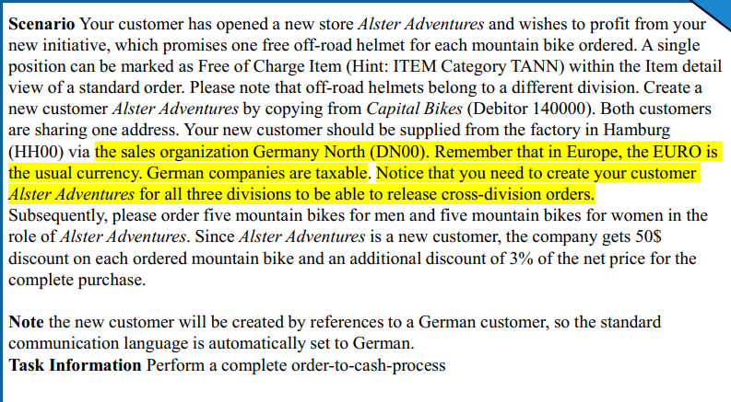

## Datasheet

|  |  |  |
| --- | --- | --- |
| Type (Organizational Data  /Master Data/Transaction Data) | Data | Number |
| Master Data | Business Partner (Customer) | 1003422 |
| Transaction Data | Sales Order | 220 |
| Transaction Data | Outbound Delivery | 80000088 |
| Transaction Data | invoice | 90000087 |
| Transaction Data | Journal Entry | 90000009 |
|  |  |  |
|  |  |  |
|  |  |  |

## Process steps

### Step 1: Create Alster Adventures S25 014

Created it by copying from Capital Bikes 140001, Berlin location

Customer Number: 1003422

Ein Bild, das Text, Screenshot, Software, Zahl enthält.
–

We can see here by copying from capital bikes, we also have the DN00 Wholesales BI division which is needed later.   
Note: We only have 2 divisions but the task description SD challenge states we need to create it for all three divisions, which right now is not clear to me what this means.

Ein Bild, das Text, Reihe, Zahl, Schrift enthält.

### Step 2: Create Standard Order Part 1

Description & Screenshots

Standard Order

Ein Bild, das Text, Screenshot, Software, Schrift enthält.

....

### Step 3: Create Standard order Part 2

Ein Bild, das Text, Software, Zahl, Reihe enthält.

### Step 4: Details about pricing conditions

Women Bikes

RA00 Discount from Net : 3%

RC00 Quantity Discount: -50€ (this is per bike so 250 total)

Ein Bild, das Text, Screenshot, Zahl, Software enthält.

Men Bikes (same as Women above)

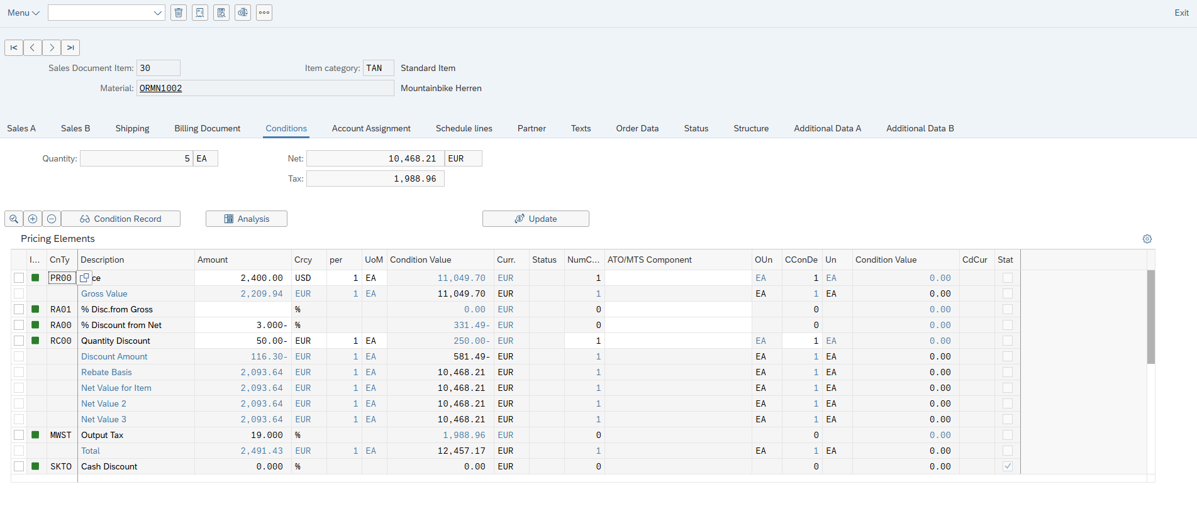

### Step 5: Finish Sales Order



### Step 6: Track Sales Order

### Create Outbound Delivery

Used sales document: 220 -> pressed button <create deliveries>

### Manage Outbound deliveries

### Outbound Delivery Saved

### Pick Outbound Delivery

### Goods picked & POST GI was successful

### Create Billing Document

Sales Document: 80000088

### Manage Billing Document

Here we can overview the correct state.

### Process Flow Overview

# PP Challenge

## Task

## Datasheet

|  |  |  |
| --- | --- | --- |
| Type (Organizational Data  /Master Data/Transaction Data) | Data | Number |
|  |  |  |
|  |  |  |
|  |  |  |
|  |  |  |
|  |  |  |
|  |  |  |
|  |  |  |
|  |  |  |

## Process steps

### Step 1: Create ....

Description & Screenshots

### Step 2: Create ....

Description & Screenshots

### Step 3: Create ....

Description & Screenshots

### Step 4: Create ....

Description & Screenshots

### Step 5: Create ....

Description & Screenshots

### Step 6: Create ....

Description & Screenshots

# MM Challenge

## Task

## Datasheet

|  |  |  |
| --- | --- | --- |
| Type (Organizational Data  /Master Data/Transaction Data) | Data | Number |
| Master Data | Customer (Business Partner) | 1003453 |
| Transaction Data | Purchase Info Record (Bolt1014) | 5300000517 |
| Transaction Data | Purchase Info Record (TRTR1014) | 5300000522 |
| Transaction Data | Purchase Info Record (TRWH1014) | 5300000524 |
| Transaction Data | Purchase Requisition | 10001300 |
| Transaction Data | Purchase Order | 4500000190 |
| Transaction Data | Material Document | 5000000351/2025 |

## Process steps

### Step 1: Create Business Partner

Description & Screenshots

Roles

For the Vendor Roles, here we see the PO & CC

Purchasing Organisation:

Within it we also set USD currency & Payment immediately due

### Step 2 : Create purchasing info record

For all three materials the process is the same. You choose e.g. material name, price in conditions, delivery quantity etc.

Bolt:

Created (Bolt)

Completion of all 3 materials purchase info records

### Step 3: Create Purchase Requisition

All steps are the same for all 3 materials.

Bolt:

Same steps for Tire & Wheel.

Material Order

### Step 4: Create purchase order

Bolt:

### Step 5: post goods receipt for purchasing document

### Step 6: Check for stock

Here its shown for bolts

# Logistics Case Study

## Task

## Datasheet

|  |  |  |
| --- | --- | --- |
| Type (Organizational Data  /Master Data/Transaction Data) | Data | Number |
| Master Data | Business Partner (Customer)  Sport Center S25 014 | 1003425 |
| Master Data | Business Partner (Supplier) Mid-West Supply S014 | 1003159 |
| Transaction Data | Standard Order | 239 |
| Transaction Data | Routing Group | 50000007 |
| Transaction Data | Production Version | 2514 |
| Transaction Data | Planned Orders | [2875](https://m30z.ucc.ovgu.de/sap/bc/ui2/flp) | 2876 |
| Transaction Data | Purchasing Info Records | TRFR3014 – 5300000116  CHAN1014 – 5300000107  TRHB1014 – 5300000120  TRSK1014 – 5300000126  TRTR1014 - 5300000130  TRTB1014 – 5300000136  TRWH1014 – 5300000144  BOLT1014 - 5300000151 |
|  |  |  |
|  |  |  |
|  |  |  |

## Process steps

### Step 1: Create Business Partner / Customer

Description & Screenshots

Ein Bild, das Text, Screenshot enthält.

### Step 2: Create Sales Order

Issue with my material : DXTR3014. This issue was resolved within class for my particular case.

Task – Discuss the availability date

In my case 03/22/2025 comes about as the 10 day delivery time for the item.

Ein Bild, das Text, Screenshot, Zahl, Software enthält.

Step 3: Show Manage Material Coverage

Plant: MI00

Stock: 0

Ein Bild, das Text, Screenshot, Software, Zahl enthält.

### Step 3: Display multilevel BOM ....

Description & Screenshots

TRWA1014

Includes:

* TRTR1014 – Touring Tire Quantity: 1
* TRTB1014 – Touring Tube Quantity: 1
* TRWH1014 – Touring Aluminum Wheel Quantity: 1
* BOLT1014 – Socket Head Bolt 5x20mm Quantity: 2

Create Alternative

Example shown for TRWA1014

Ein Bild, das Text, Software, Computersymbol, Multimedia-Software enthält.

TRWA1014 - Alternative: 02

Ein Bild, das Text, Screenshot, Zahl, Schrift enthält.

DXTR3014 – Alternative: 02

Ein Bild, das Text, Screenshot, Zahl, Schrift enthält.

DXTR3014

Includes:

* TRWA1014 – Touring Alininum Wheel Assembly Quantity: 2
* TRFR3014 - Touring Frame-Red Quantity: 1
* CHAN1014 – Chain Quantity: 1
* TRHB1014 - Touring Handle Bar Quantity: 1
* TRSK1014 - Touring Seat Kit Quantity: 1

Ein Bild, das Text, Screenshot, Zahl, Software enthält.

Final Step -Display Multilevel BOM

Ein Bild, das Text, Reihe, Screenshot, Zahl enthält.

### Step 4: Create Routing

Description & Screenshots

TRWA1014

Here we see I chose Alt. BOM 2 for my prior created alternative.

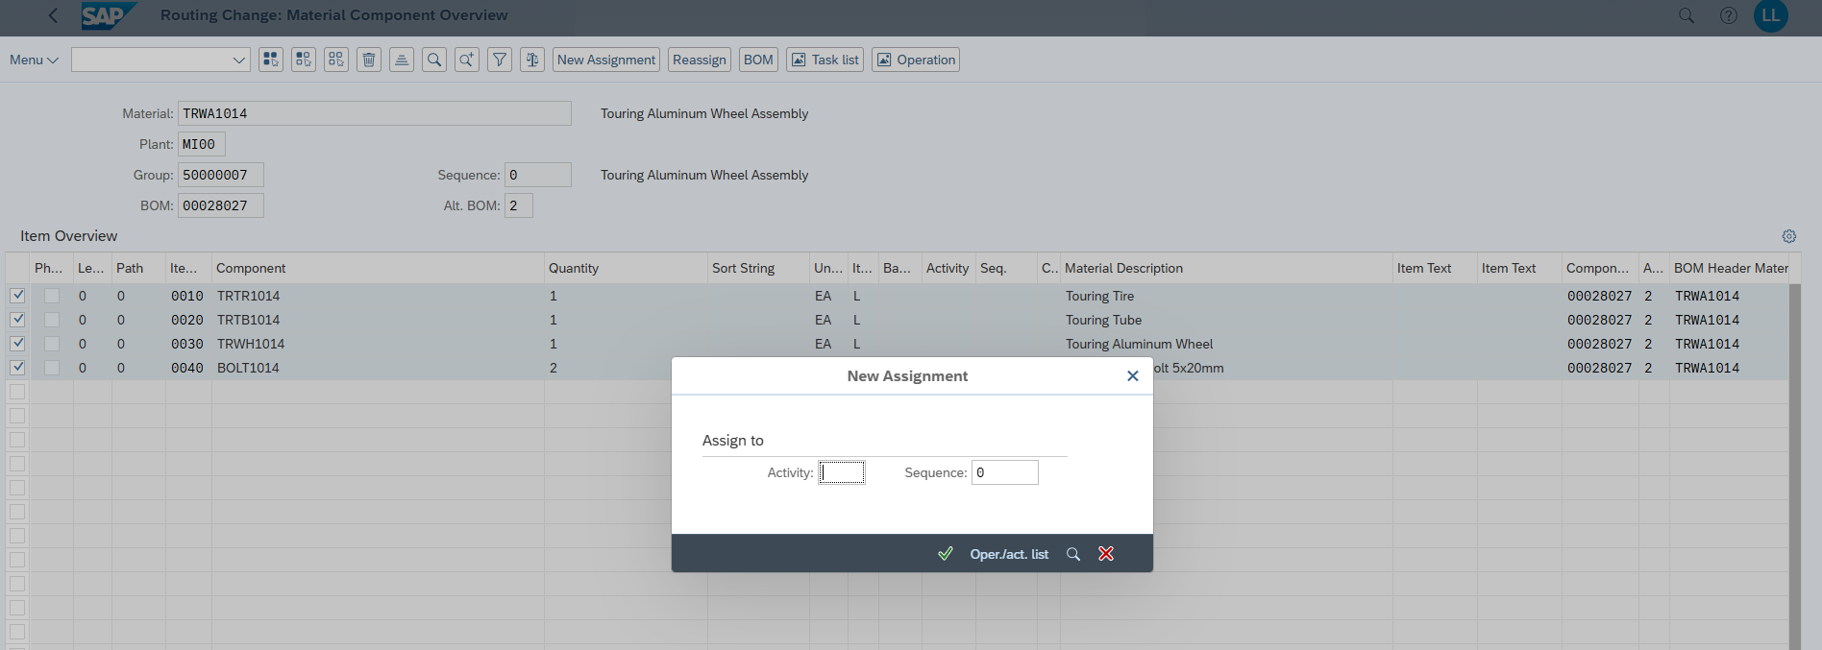

I chose the entries -> New assignment -> Oper/act list -> chose assembly and saved the already existing routing or rather updated it with the Alt. Bom of 2DX

Ein Bild, das Text, Screenshot, Software, Computersymbol enthält.

DXTR3014

Again Alt. Bom of 2

Ein Bild, das Text, Screenshot, Zahl, Schrift enthält.

Ein Bild, das Text, Screenshot, Software, Multimedia-Software enthält.

Saved

Ein Bild, das Text, Screenshot, Software, Computersymbol enthält.

### Step 5: Production Versions

Description & Screenshots

TRWA1014

Production Version: 2514 (as requested in teams chat)

Alternative BOM: 2

Group (Routing): 50000007

Ein Bild, das Text, Screenshot, Software, Zahl enthält.

DXTR3014

Production Version: 2514 (as requested in teams chat)

Alternative BOM: 2

Group (Routing): 50000007

Ein Bild, das Text, Screenshot, Software, Computersymbol enthält.

Verification creation of Production Versions for TRWA1014 & DXTR3014

Ein Bild, das Text, Schrift, Reihe, Screenshot enthält.

### Step 6: Material Requirements Planning (MRP)

Description & Screenshots

Select my BOM with alternative 2 and the other materials

Ein Bild, das Text, Screenshot, Software, Zahl enthält.

Screenshot of MRP run and overview in app. DXTR3014 is processed now.

Planned Order: 2875

TRWA1014

### Step 7: Purchasing Info Records

All 8 items. The records were there already from last year but with huge prices and those I changed to be more reasonable as you described in the task.

